MITCHELL D. ERICKSON, Ph. D.

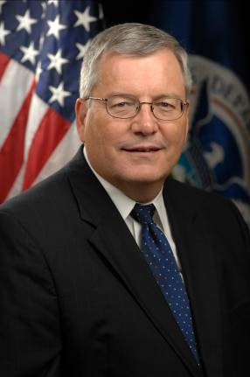 | PAUL WEDIG
Mitchell D. Erickson, Ph.D.
Director, Northeast Operations
Interagency and First Responder Programs
Science and Technology Directorate
U.S. Department of Homeland Security
Mitchell.erickson@dhs.gov
Mitch Erickson facilitates DHS’ Science & Technology activities with other federal, state, tribal and territorial agencies and science/technology performers in the Northeast (NJ to ME) and Caribbean (PR and USVI). He works with appropriate organizations in the Northeast to integrate vertically among the various organizations and horizontally across all threats. Dr. Erickson facilitates S&T projects within this region, such as field tests. He provides a conduit to subject matter experts for government homeland security agencies and first responders. He also evaluates current practices that could be improved by application of new technologies, models, systems, or approaches and where S&T can contribute to help close these homeland security gaps. Several colleagues cover other geographic and technical aspects of this interagency coordination function.

Dr. Erickson has had various technical and management positions. Most recently he was the Director of DHS’ Environmental Measurements Laboratory for over a decade. Dr. Erickson’s prior research in environmental science and analytical chemistry has developed novel technologies, identified sources and fates of pollutants, investigated chemical reaction conditions, and produced improved analytical methods, particularly with respect to PCBs, chlorinated dioxins and furans, and radionuclides. Dr. Erickson earned a Ph.D. in Chemistry from the University of Iowa in 1976. He has published two books--Analytical Chemistry of PCBs, (now in its 2nd Edition) and Remediation of PCB Spills. Dr. Erickson holds one patent, is the author of over 150 technical publications, and has given over 160 technical presentations.

