Science and Technology in Disasters— Opportunities Revealed by Sandy
Mitchell D. Erickson
DHS S&T
Mitchell.erickson@hq.dhs.gov
202-255-2312

Abstract

Hurricane Sandy was one of the most devastating storms in US history, hitting an area not frequently impacted by hurricanes. The preparations for, response to, and recovery from Sandy provide many lessons learned and opportunities for improvement. They also give us a platform for building resiliency as America faces a future of increasingly extreme weather, rising sea levels, growing populations in impact zones, and increasingly interconnected infrastructure.
Two key components are emergency management and critical infrastructure protection. These separate, but highly interrelated functions are discussed in detail below the gap tables.
As we look to the future and the next disaster, it is critical that we learn from prior disasters, improve, and apply the best technologies, systems, tools, and knowledge available to address the challenges. Thus, it is important to infuse emergency management and infrastructure protection with the tools that science and technology can provide, through the leadership of the DHS Science and Technology Directorate (DHS S&T).
Sandy provided a lens to focus attention on capability gaps. Some of these capability gaps would require funded projects from DHS S&T or other agencies; and others, simply a clear articulation of the need for the private sector, inventors, app developers, or motivated citizens. Some will require years of research, but many should be solvable in the near future.
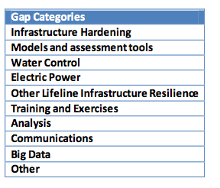
This presentation will discuss the gaps, challenges and potential solutions.

