Directions from the Hilton Garden Inn to Groton School
From Google Maps:
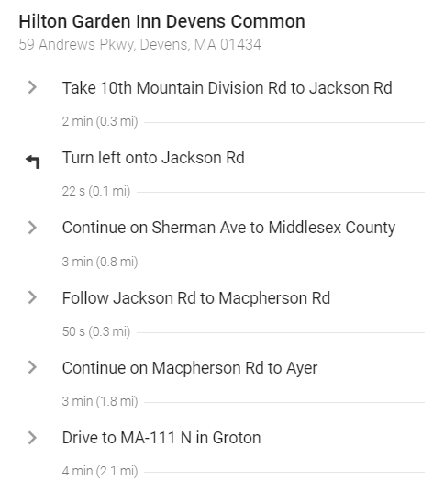 | 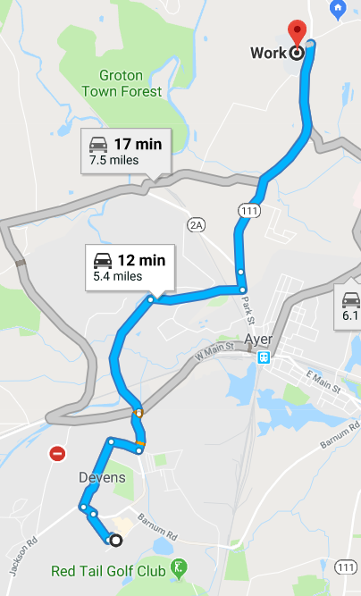

Macpherson Road is a quiet back road which passes along the Nashua River, avoiding the frequently nightmarish intersection of West Main Street and Route 111 North. The entrance to the road is directly across from the gate at Devens; do not be intimidated by the large open gate; there is an exit at the other end.
Once the campus is in sight at the top of the hill, enter through the north gate which is the second left after the chapel and is signed “Athletics”. Park in the lot in front of the Athletic Center. The School house is the large building directly south of this lot.
I have shown the closest entrance to my classroom (see map below)
The classroom is number 032 (quite European, the ground floor is 0; long story), located in the northwest corner of the building.

