DIMACS Working Group on Phylogenetic Trees and Rapidly Evolving Pathogens
Report on first meeting

Contents

Overview
Participants
Talks
Abstracts
Working group meeting
Appendix 1: Objectives
Appendix 2: Email contact list

Overview

The first meeting of the working group was held at the INCOB 2004 (International Conference on Bioinformatics) in Auckland, New Zealand, 2004. All nine members of the working group attended, and presented talks during the DIMACS symposium on Phylogenetic trees and rapidly evolving pathogens, which also included some other associated researchers. The working group also met formally in a closed session during the conference.

Participants

Allen Rodrigo
Bioinformatics Institute, University of Auckland
Auckland, New Zealand
e-mail: a.rodrigo@auckland.ac.nz

Mike Steel
Biomathematics Research Centre, University Of Canterbury,
Christchurch, New Zealand
e-mail: m.steel@math.canterbury.ac.nz

Alexei Drummond
Department of Zoology, University of Oxford, South Parks Road, Oxford, UK e-mail: alexei.drummond@zoology.oxford.ac.uk

Thomas Leitner
Theoretical Biology and Biophysics, Los Alamos National Laboratory,
Los Alamos, NM, USA e-mail: tkl@lanl.gov

Geoff Nicholls
Department of Mathematics, University of Auckland, Private Bag 92019, Auckland, New Zealand e-mail: gk.nicholls@auckland.ac.nz

Roderic D. M. Page
Institute of Biomedical and Life Sciences, University of Glasgow, Glasgow G12 8QQ, United Kingdom
e-mail: r.page@bio.gla.ac.uk

Bruce Rannala
Department of Medical Genetics, University of Alberta, 839 Medical Sciences Building
Edmonton, Alberta T6G 2H7, Canada
e-mail: brannala@ualberta.caMarc A. Suchard
Department of Biomathematics, David
Geffen School of Medicine at UCLA, Los Angeles, CA 90095
e-mail: msuchard@ucla.edu

Jeff Thorne
Bioinformatics Research Center, Box 7566
North Carolina State University
Raleigh NC 27695-7566 e-mail: thorne@statgen.ncsu.edu

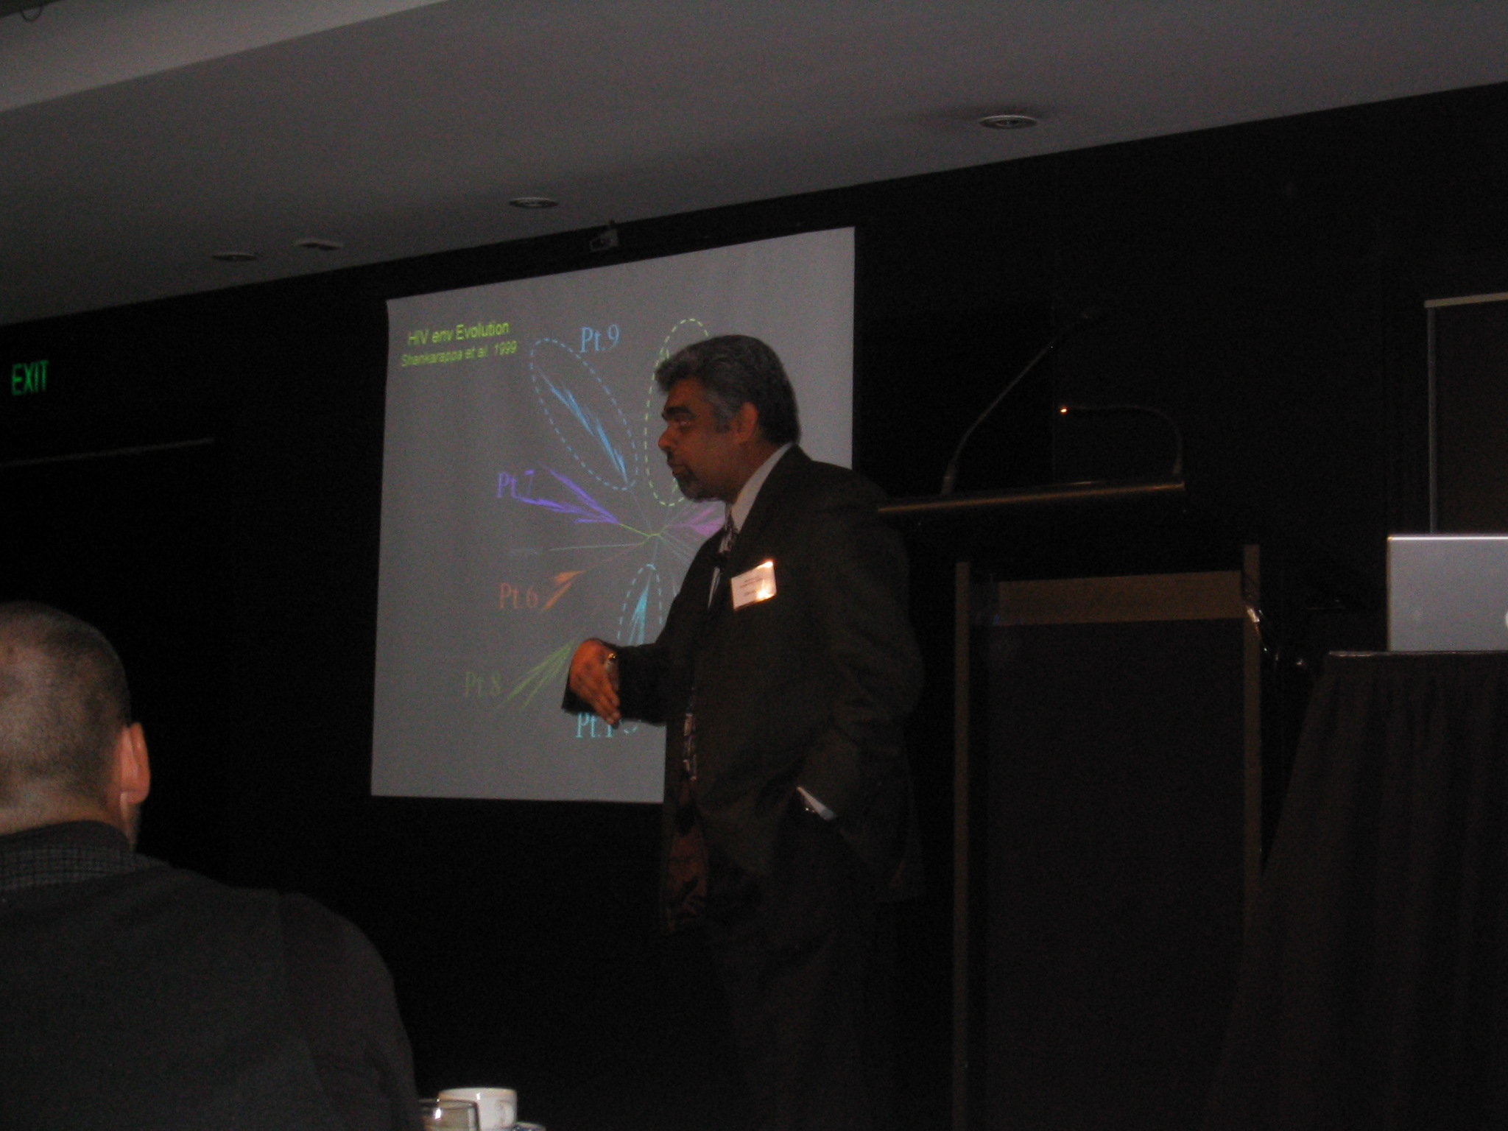
Left: Allen Rodrigo talking about his recent work on measurably evolving populations

The DIMACS Symposium on Phylogenetics and Rapidly Evolving Pathogens

TALK TITLES

Tuesday, 7 September 2004

Tuesday, 7 Sept, 0900 – 0940 Mike Steel, University of Canterbury
Phylogenetic networks and biodiversity

Tuesday, 7 Sept, 0945 – 1025 Roderic Page, University of Glasgow
Viruses, clocks, and cospeciation

Tuesday, 7 Sept, 1100 – 1140 Thomas Leitner, Los Alamos National Laboratories
Recombination, 3D network structure, multiple transmission, and subpopulation frequency shifts in a mother-to-child transmission case.

Tuesday 7 Sept, 1145 – 1225 Marc Suchard, University of California, San Diego
Resolving the intra-host evolution of rapidly evolving pathogens: common
patterns and shared indel information under a Bayesian framework

Tuesday 7 Sept, 1400 – 1440 Alexei Drummond, University of Oxford
Modeling virus evolution and population dynamics

Tuesday, 7 Sept, 1445 – 1325 Jeff Thorne, North Carolina State University
Making evolutionary inferences when there is dependent change among sequence positions, with emphasis on protein tertiary structure and viral antigenicity.

Wednesday, 8 September 2004

Wednesday, 8 Sept 0900 – 0940 Bruce Rannala, University of Alberta
Imperfect molecular clocks

Wednesday, 8 Sept, 0945 – 1025 Geoff Nicholls, University of Auckland
Measurably evolving memes: new models and inference tools for meme-trait data

Wednesday, 8 September 1100 – 1120 Ben Redelings, University of California, San Diego
Phylogeny and alignment

Wednesday, 8 Sept, 1120 – 1140 Gregory Ewing, University of Auckland
Measurably evolving populations and the structured coalescent

Wednesday, 8 Sept 1145 – 1225 Allen Rodrigo, University of Auckland
Measurably evolving populations: where to next?

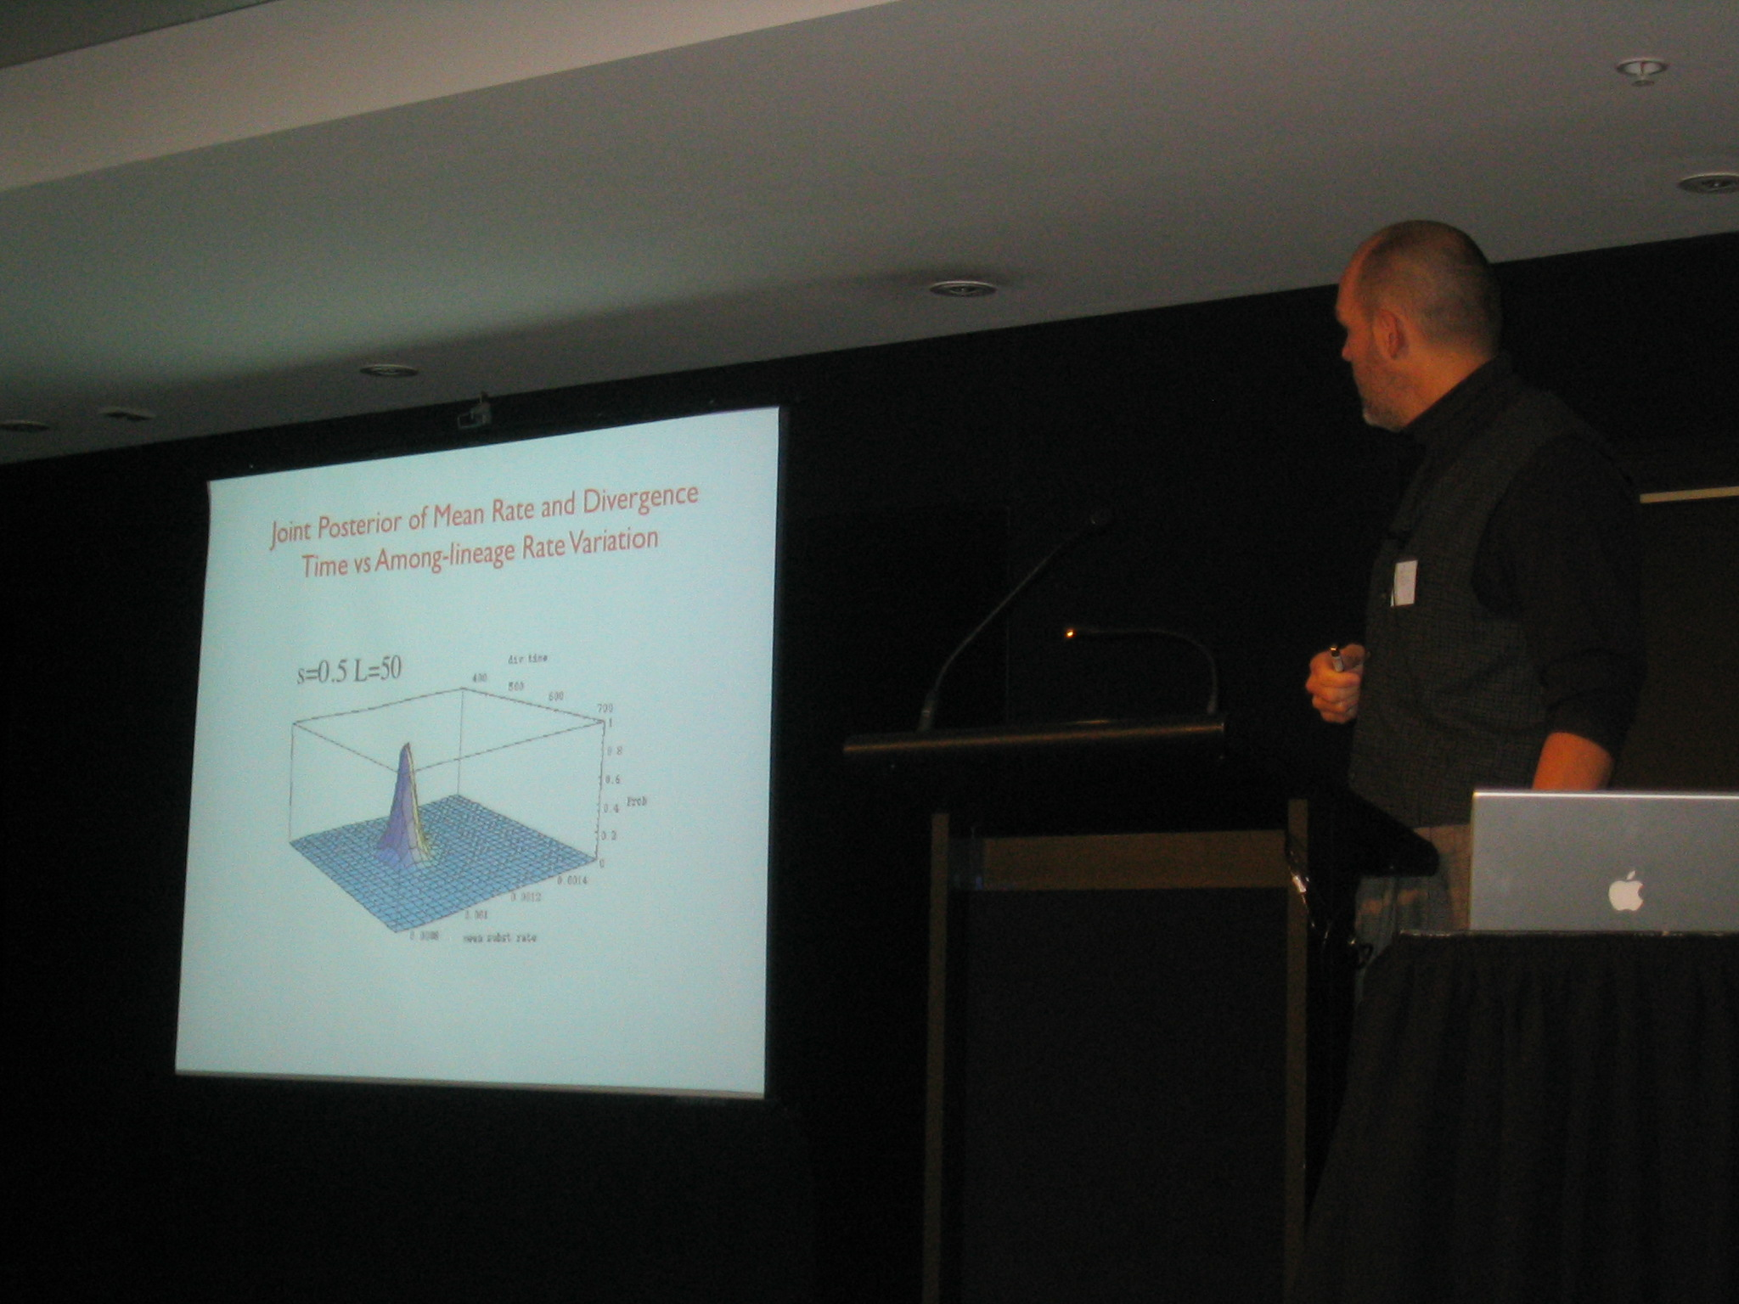
Left: Bruce Rannala talking on Bayesian techniques for dating divergences

TALK ABSTRACTS

Modeling Virus Evolution and Population Dynamics

Alexei Drummond

Department of Zoology, University of Oxford, South Parks Road, Oxford, UK

e-mail: alexei.drummond@zoology.oxford.ac.uk

Modeling population dynamics and molecular evolution of viruses is of central important to understanding diseases caused by pathogens such as HIV-1, human Influenza A and Hepatitis C. Furthermore, virus evolution is an excellent framework for understanding the interplay between basic evolutionary processes such as mutation, drift, selection and recombination and population dynamics. In this talk I will outline some recent advances in the modeling of virus evolution as well as some tests of the adequacy of these models. I will also outline the nascent field of "phylodynamics" in which virus genetic variation and virus population dynamics are considered within a single coherent framework. Finally I will outline some open questions and problems in the field of
virus evolutionary dynamics.

The Structured Coalescent With Serially-Sampled Sequences

Greg Ewing^{1,2}*, Geoff Nicholls^{1,3} and Allen Rodrigo^{1,2}

1Bioinformatics Institute, School of Biological Sciences, University of Auckland,
Private Bag 92019, Auckland, New Zealand
²Alan Wilson Centre, Massey University, Palmerston North, New Zealand
³Department of Mathematics, University of Auckland, Private Bag 92019,
Auckland, New Zealand
*e-mail: gewi001@ec.auckland.ac.nz

We present a Bayesian approach for simultaneously estimating mutation rate, population sizes and migration rates in an island structured population, using temporally and spatially disjoint sequence data. We estimate migration history and rates from the DNA sequences taken at different times and from different tissues. We fit a model of the joint genealogy and migration process using MCMC over a space of trees labeled with migration events. Since the number and timing of migration events is unknown the MCMC must satisfy detailed balance between states in spaces of unequal dimension. A real HIV DNA sequence dataset with 2 demes, semen and blood, is used as an example to demonstrate the method by fitting asymmetric migration rates and different population sizes. This dataset exhibits a bimodal joint posterior distribution, with modes favouring different preferred migration directions.

Recombination, 3D Network Structure, Multiple Transmission and Subpopulation Frequency Shifts in a Mother-to-child Transmission Case

T Leitner¹*, F Salvatori², C Ripamonti², C-S Tung¹, E Halapi³, M Jansson³, G Scarlatti²

¹Theoretical Biology and Biophysics, Los Alamos National Laboratory,
Los Alamos, NM, USA
²Unit of Immunobiology of HIV, DIBIT, San Raffaele Scientific Institute, Milan, Italy
³MTC, Karolinska Institute, Stockholm, Sweden
*e-mail: tkl@lanl.gov

Mother-to-child transmission displays a special case of transfer of an infectious agent. The passage of the agent can take several routes into its new host, and it may do so during a long period of time. Here, we report on a case where at least four different HIV-1 variants were transmitted from mother to child. We investigated the evolution of the virus from its start in the mother during pregnancy, through transmission to the child, and followed to the end of the disease progression of the child using phylogenetic and biological analyses. The natural history of the child was followed by clinical analyses. Standard tree analysis was not able to describe the mother's virus population. A new 3D network approach, however, could reveal the complex structure of this population. It was evident that multiple intrapopulation recombination events had taken place between predicted R5 and X4 genotypes. The mother then transmitted at least four different virus variants to her child. Immediately after birth a monophyletic R5 tropic population was detected, but already after one month, an independent X4R5 dual tropic population emerged and established a second subpopulation. During months 2 and 20 the frequencies of the subpopulations in the child fluctuated, and the X4R5 gradually become more dominant. Towards the end of the disease progression, at 33 months, subpopulation two completely took over and became genetically homogeneous. At 38 months the child died. Hence, the evolution in the child seemed to be mainly driven by intergroup selection, rather than recombination as in the mother. The resulting genetic race may have caused the virus to rapidly adapt into a more pathogenic form that apparently worsened the disease progression.

Measurably Evolving Memes: New Models and Inference Tools for Meme-trait Data

Geoff Nicholls

Department of Mathematics, University of Auckland, Private Bag 92019, Auckland, New Zealand
e-mail: gk.nicholls@auckland.ac.nz

We were inspired by some data (Gray & Atkinson 2003, Nature v426 pp435-439) measuring the evolution of human language. The data is essentially binary trait data in which languages play the role of individuals and the descriptive traits are homologous words. The data record the values of around 2500 traits in 87 Indo-European languages, and include time-stamped fossil languages (such as Hittite). We setup a model of trait-evolution. The model can be thought of as a stochastic variant of Dollo parsimony in which language histories are trees. They are modelled via a branching process of sets.
Set elements are trait labels, created (uniquely) at constant rate and destroyed at constant per capita rate. The birth times of traits recorded in sampled languages are biased towards the tree leaves. Because the traits evolve measurably, historical records of language change can be used to determine model rates. We fit the model to data using our own MCMC code.

Viruses, Clocks, and Cospeciation

Roderic D. M. Page
Institute of Biomedical and Life Sciences, University of Glasgow
Glasgow G12 8QQ, United Kingdom
e-mail: r.page@bio.gla.ac.uk

Fully understanding the evolutionary history of a virus-host interaction requires reconstructing the history of that association. Much of the methodology for doing this has been developed in the context of animal parasites (such as the celebrated gopher-louse example). Here I review recent developments in comparing host and parasite phylogenies, with an emphasis on the role estimates of evolutionary time can play in reconstructing host-parasite evolutionary history. I then outline some methodological problems facing this research, such as the assumption that host and parasite evolutionary history is tree-like, the lack of adequate models of cospeciation, and the reliance on a single estimate of host and parasite tree.

Imperfect Molecular Clocks

Bruce Rannala

Department of Medical Genetics, University of Alberta, 839 Medical Sciences Building
Edmonton, Alberta T6G 2H7, Canada
e-mail: brannala@ualberta.ca

The original "molecular clock hypothesis" proposed that amino acid substitutions (and by extension nucleic acid substitutions) occur according to a stochastic process with a relatively constant rate per year across species. This led to the development of methods for estimating species divergence times, etc, using molecular data and one or more independently dated fossil "calibration points." Statistical tests of the molecular clock indicate that it is often violated. Substitution rates can vary across lineages due to natural selection, generation time effects, population structure, etc. Accounting for variation in substitution rates is especially important when considering rapidly evolving species such as pathogenic bacteria or viruses that are under constant selective pressure from the host immune system and occur in large fragmented populations. In recent years, several statistical methods have been proposed for estimation of divergence times using an imperfect molecular clock for which the rate of substitution is allowed to vary across lineages according to a stochastic model. Models of across-lineage substitution rate variation are described and contrasted highlighting their potential strengths and weaknesses.

Incorporating Indel Information Into Phylogeny Estimation for Rapidly Emerging Diseases

Benjamin D. Redelings* and Marc A. Suchard

Department of Biomathematics, David Geffen School of Medicine at UCLA,
Los Angeles, CA 90095-1766
*e-mail: bredelin@ucla.edu

Phylogenies of rapidly evolving pathogens can be difficult to resolve because of the small number of substitutions that accumulate in the short times since divergence. In order to improve resolution of such phylogenies we propose using indel information in addition to substitution information by simultaneously estimating the alignment and phylogeny. We accomplish this using a joint reconstruction model in a Bayesian framework and draw inference using Markov chain Monte Carlo (MCMC). We introduce a novel Markov chain transition kernel that improves computational efficiency by proposing non-local topology rearrangements and by block sampling alignment and topology parameters. We demonstrate the relevance of indel information in examples drawn from HBV, HIV, and SIV and discuss the importance of taking alignment uncertainty into account when using such information. We also develop a non-codon-based technique that avoids alignments with frame-shift mutations when analyzing coding sequences. We compare the performance of this non-codon-based technique with codon-based models in handling molecular sequences from rapidly evolving diseases.

Measurably Evolving Populations: Where to Next?

Allen Rodrigo

Bioinformatics Institute, University of Auckland
Auckland, New Zealand
e-mail: a.rodrigo@auckland.ac.nz

A Measurably Evolving Population (MEP) is defined as any population for which sequences sampled at different times show a statistically significant increase in substitutions. In this talk, I explore the consequences of this definition, and review the advances made in the development of methods for analysing the evolutionary genetics of MEPs. I conclude by examining what remains to be done, and the extent to which these goals are achievable.

Phylogenetic Networks and Biodiversity

Mike Steel

Biomathematics Research Centre, University Of Canterbury,
Christchurch, New Zealand
e-mail: m.steel@math.canterbury.ac.nz

Phylogenetic trees are central to evolutionary molecular biology, and associated areas such as molecular epidemiology. In this talk I describe some recent and new theory concerning the use of sequence-based and character-based data for reconstructing and analying phylogenetic trees and networks, and indicate how they may be useful for future applications.

Resolving the Intra-host Evolution of Rapidly Evolving Pathogens: Common
Patterns and Shared Indel Information Under a Bayesian Framework

Marc A. Suchard

Department of Biomathematics, David
Geffen School of Medicine at UCLA, Los Angeles, CA 90095
e-mail: msuchard@ucla.edu

Intra-host phylogenies of rapidly evolving pathogens can be difficult to resolve because of the small number of substitutions that accumulate in the short time since infection. Nonetheless, gaining an understanding of the intra-host evolution has implications for the development of novel medical therapies. I will discuss Bayesian hierarchical phylogenetic models (HPMs) as one approach to improving resolution by analyzing pathogen evolution across multiple infected subjects simultaneously. The hierarchical
framework both pools information across subjects to improve intra-host estimate precision and permits estimation and hypothesis testing of across-subject-level parameters while taking appropriate consideration of subject variability and uncertainty. The HPM assumes standard hierarchical priors on continuous evolutionary parameters and a multinomial prior structure on topologies across subjects. I will illustrate the utility of the HPM with a question regarding HIV-1 compartmentalization by examining subjects whose viral populations exhibit a shift in coreceptor utilization in response to antiretroviral therapy. CXCR4 (X4) strains emerge in all patients, but are suppressed following initiation of new regimens, so that CCR5 (R5) strains predominate. A Bayes factor approach that tests for common patterns across subjects finds that re-emergent R5 virus detectable after therapy is more closely related to predecessor R5 virus than to the X4 strains. If time permits, I will outline a second approach to improving the resolution of intra-host phylogenies. This approach employs shared indel information in addition to substitution information between sequences by simultaneously estimating the alignment and phylogeny. I accomplish this using a joint Bayesian reconstruction model that provides measurements of uncertainty on the alignment, the topology and all other evolutionary parameters.

Making Evolutionary Inferences When There is Dependent Change
Among Sequence Positions, With Emphasis on Protein Tertiary
Structure and Viral Antigenicity

Jeff Thorne
Bioinformatics Research Center, Box 7566
North Carolina State University
Raleigh NC 27695-7566
e-mail: thorne@statgen.ncsu.edu

The relationship between genotype and phenotype is central to evolution. Unfortunately, probabilistic models of sequence evolution typically ignore phenotype when describing how genotypes change. Two general difficulties are largely responsible for this shortcoming of widely used models. The first problem is that the relationship between genotype and phenotype tends to be difficult to quantify. Ideally, the set of possible genotypes could be numerically ranked according to the fitness of the phenotype that they specify. If this could be accomplished, rates of sequence changes that improve fitness could be modelled as being high whereas rates of changes that decrease fitness would be low. The second problem is that the biologically plausible incorporation of fitness into models of sequence evolution would likely produce dependence among nucleotide substitutions that occur at different sequence sites. A consequence of this dependence is the computational infeasibility of conventional methods for making evolutionary inferences.

We have been developing procedures for statistical inference when dependent change among sites is built into evolutionary models. We illustrate these techniques with results from our studies on the evolutionary relationship between protein tertiary structure (phenotype) and protein-coding DNA sequences (genotype). We then speculate on the potential for similar statistical techniques to illuminate the study of viral evolution. Specifically, we are beginning to explore the potential for these techniques to quantify the effects of the host immune system on shaping viral genomes.

Working Group Meeting 3.30—5pm. September 7th

Present: Allen Rodrigo, Howard Ross, Rod Page, Bruce Rannala, Jeff Thorne, Alexei Drummond, Marc Suchard, Geoff Chase, Thomas Leitner,

Much discussion revolved around the right biological requirements for models. Allen Rodrigo suggested the formulation of better synthetic models (to handle several situations – recombination, serial sampling, migration, selection etc) and the question of how much data would be needed to discriminate these effects. Rod Page was interested in the modeling of gene duplication and horizontal gene transfer in molecular epedimiology. Bruce Rannala saw a need for applying empirical estimators to handle more realistic models that could not be analytically handled. Geoff Chase saw a need for better techniques for testing between models, while Thomas Leitner said it be worthwhile developing techniques to handle transmission, bottleneck effects, recombination and site saturation.

There was further discussion about possible dates (and additional investigators) for a future meeting – subsequently it was decided that this second meeting should be around June 2006 at DIMACS (Rutgers). Meantime many of the participants will meet at the Evolution meeting in Fairbanks, Alaska in June 2005, and/or at the planned ‘Mathematics and Evolution’ IHP meeting in Paris, June 2005, as well as other ongoing discussions.

Appendix One: Objectives

This working group will build on phylogenetic methods developed by computational biologists to explore ways in which such methods can be applied and developed to shed new light on the origin, evolution, and likely future development of viruses and other pathogens. Phylogeny is now a central tool for studies into the origin and diversity of viruses such as HIV (see, e.g., [Pybus, Rambaut and Harvey (2000), Rambaut, Robertson, Pybus, Peeters and Holmes (2001),]) and dengue fever virus [Rambaut (2000)]. These and other investigations have provided new insights, such as identifying the possible pattern of transfer of HIV-type viruses between primate species. Phylogenetic techniques have also proved useful in mapping the evolution of different strains of the human influenza A virus [Bush, Bender, Subbarao, Cox and Fitch (1999a), Bush, Fitch, Bender and Cox (1999b)], with the goal of predicting which strain is most likely to cause future epidemics, with applications to vaccine development. Many of the phylogenetic techniques in use were originally developed to investigate more traditional and well-behaved evolutionary problems, where historical relationships are typically represented by a binary tree with a small number of species appearing as the leaves (tip vertices). In epidemiology the picture is more complex and this observation underlies the task of this working group. Even if there is a single underlying tree, it may typically have thousands of vertices, and many of these may be of high degree. Furthermore, data may be available not just for the species at the leaves of the tree, but for species distributed at vertices throughout the tree, particularly when the evolution of a virus is studied by serial sampling in patients. This is true for retroviruses which have a very high substitution rate, and whose molecular evolution may be up to 106 times more rapid than eukaryotic or prokaryotic genes [Drummond and Rodrigo (2000), Rodrigo, Shpaer, Delwart, Iversen, Gallo, Jurgen Brojatsch, Hirsch, Walker and Mullins (1999), Shankarappa, Margolick, Gange, Rodrigo, Upchurch, Farzadegan, Gupta, Rinaldo, Learn, He, Huang and Mullins (1999)]. New methods for dealing with these complications will be investigated. To complicate the picture further, it may well be more appropriate to represent the evolution of a virus by a collection of trees, or by a digraph (or network) to recognize the "quasispecies" nature of viruses, such as in the application of split decomposition by Dopazo, Dress, and von Haeseler [Dopazo, Dress and von Haeseler (1993)]; we shall pursue this direction of research. Relating population genetics considerations (currently handled by the "coalescent" model) to phylogeny considerations is also potentially useful [Rodrigo and Felsenstein (1999)]. However, even here, theory has yet to be developed. For instance, the fact that retroviral evolution occurs within a host means that viral sequences sampled from different hosts must take account of the different dynamics of between-host transmission histories and within-host viral genealogies [Rodrigo (1999)]. This has consequences for the inference of epidemiological parameters based on viral sequences obtained from several hosts, and we will investigate them. Finally, if one wishes to test particular epidemiological hypotheses it would be helpful to have techniques that avoid having to fix attention on one particular tree. This suggests devising fast methods that would average the quantities of interest over all likely trees, weighted by how well they describe the data - a challenge for modern computational tools and our working group.
This meeting is by invitation only. If you are interested in participating, please contact the organizers.

References:
Bush, R.M., Bender, C.A., Subbarao, K. Cox, N.J., and Fitch, W.M. (1999a), "Predicting the evolution of human influenza A," Science, 286, 1921-1925.
Bush, R.M., Fitch, W.M., Bender, C.A., and Cox, N.J. (1999b), "Positive selection on the H3 Hemagglutinin gene of human influenza virus A," Mol. Biol. Evol., 16, 1457-1465.
Dopazo, J., Dress, A., and von Haeseler, A. (1993), "Split decomposition: A technique to analyse viral evolution," Proc. Natl. Acad. Sci. USA, 90, 10320-10324.
Drummond, A., and Rodrigo, A.G. (2000), "Reconstructing genealogies of serial samples under the assumption of a molecular clock using serial-sample UPGMA (sUPGMA)," Molecular Biology and Evolution, 17, 1807-1815.
Pybus, O. Rambaut, A., and Harvey, P.H. (2000), "An integrated framework for the inference of viral population history from reconstructed genealogies," Genetics, 155, 1429-1437.
Rambaut, A. (2000), "Estimating the rate of molecular evolution: incorporating non-contemporaneous sequences into maximum likelihood phylogenies," Bioinformatics, 16, 395-399.
Rambaut, A., Robertson, D.L., Pybus, O.G., Peeters, M., and Holmes, E. (2001), "Phylogeny and the origin of HIV-1," Nature, 410, 1047-1048.
Rodrigo, A.G. (1999), "HIV evolutionary genetics [Commentary]," Proceedings of the National Academy of Sciences, 96, 10559-10561.
Rodrigo, A.G., and Felsenstein, J. (1999), "Coalescent approaches to HIV-1 Population Genetics," in K.A. Crandall (ed.), Molecular Evolution of HIV, Johns Hopkins University Press.
Rodrigo, A.G., Shpaer, E.G., Delwart, E.L., Iversen, A.K.N., Gallo, M.V., Jurgen Brojatsch, J., Hirsch, M.S., Walker, B.D., and Mullins, J.I. (1999), "Coalescent estimates of HIV-1 generation time in vivo," Proceedings of the National Academy of Science, 96, 2187-2191.
Shankarappa, R., Margolick, R.B., Gange, S.J., Rodrigo, A.G., Upchurch, D., Farzadegan, H., Gupta, P., Rinaldo, C.R., Learn, G.H., He, X., Huang, X-L., and Mullins, J.I. (1999), "Consistent viral evolutionary changes associated with progression of HIV-1 infection," Journal of Virology, 73, 10489-10502.

Appendix Two: Email addresses

Alexei Drummond alexei.drummond@zoology.oxford.ac.uk
Thomas Leitner tkl@lanl.gov
Geoff Nicholls gk.nicholls@auckland.ac.nz
Roderic Page r.page@bio.gla.ac.uk
Bruce Rannala brannala@ualberta.ca
Allen Rodrigo a.rodrigo@auckland.ac.nz
Mike Steel m.steel@math.canterbury.ac.nz
Marc Suchard msuchard@ucla.edu
Jeff Thorne thorne@statgen.ncsu.edu

